Name: HARSHINI P R Regno: 192524165
Slot D – CSA1407 Compiler Design
CO3 AT1 – Experiment

1) Syntax Directed Definition (SDD)

Aim
To evaluate arithmetic expressions using Syntax Directed Definitions (SDD) with synthesized attributes.

Procedure
- Define grammar for expressions (E, T, F).
- Assign synthesized attribute val to each symbol.
- Apply rules based on operator precedence.
- Evaluate expression step by step.
- Display final computed value.

Output

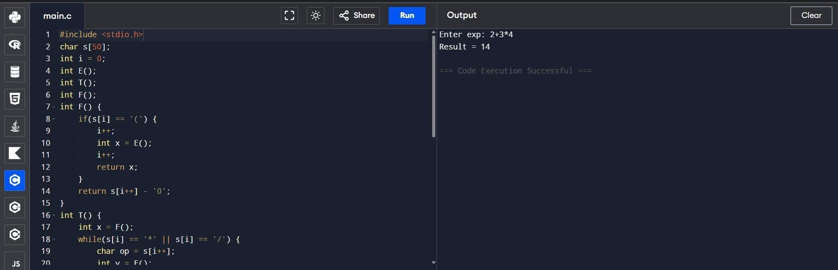
2) Postfix Evaluation
(S-Attributed) Aim
To evaluate postfix expression using stack and S-attributed definition.

Procedure
- Read postfix expression.
- Use stack for evaluation.
- Push operands into stack.
- Pop operands when operator appears.
- Perform operation and push result.
- Final stack value is result.

Output

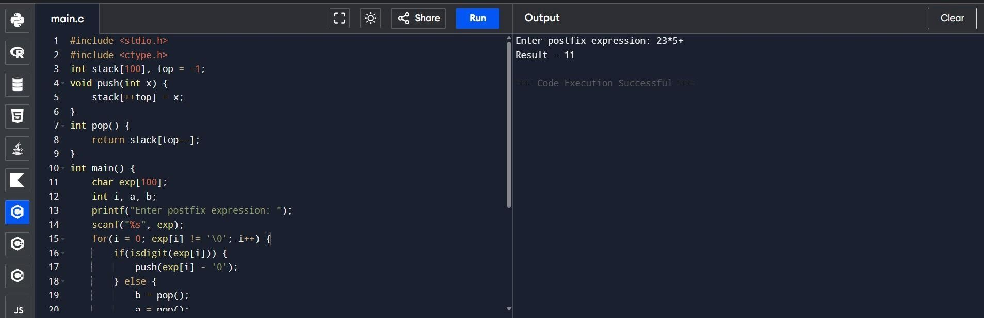
3) L-Attributed
Definition Aim
To evaluate expressions using L-attributed definitions with inherited attributes.

Procedure
- Use function parameters to pass inherited values.
- Maintain operator precedence.
- Evaluate expression in top-down manner.
- Return computed result.

Output

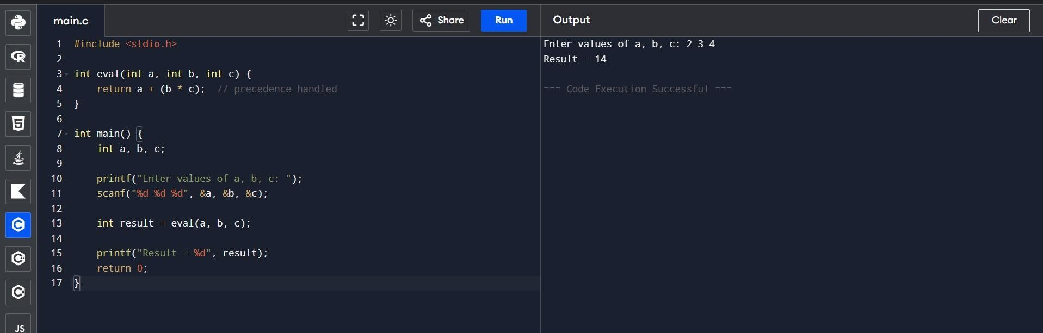
4) Type
Equivalence Aim
To check whether two type expressions are equivalent.

Procedure
- Accept two type strings.
- Compare both strings.
- Check pointer levels (*).
- Display result.

Output

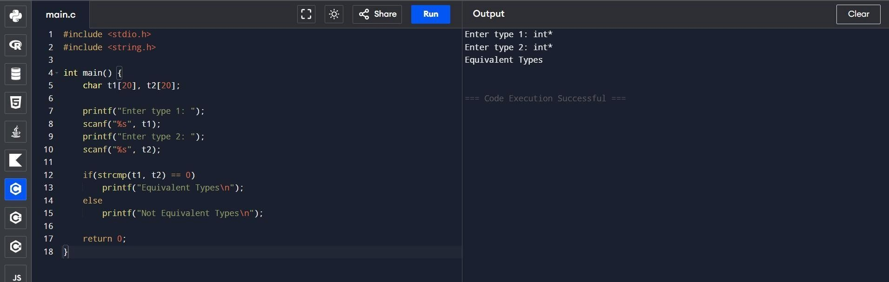

5) Type Checking (Semantic
Analysis) Aim
To detect type errors in arithmetic expressions.

Procedure
- Accept operand types.
- Check compatibility.
- Allow valid operations.
- Display error for invalid types.

Output

